192525074_RAVURU PRANATHI_CO1_AT1

SIMATS ENGINEERING
ASSESSMENT TOOL 1

COURSE NAME: Database Management Systems COURSE CODE: CSA0504

COURSE OUTCOME COVERED
CO1: Analyze DBMS architecture, different data models, schema types, and design ER/EER diagrams, relational schemas for case-based scenarios by identifying entities and relationships. (BL1, BL2)
Activity Tool : Short Answer Text(High) Assessment Tool
Weightage: 40%

QUESTIONS
Q.  No | Question | Bloom 's Level
1 | Explain schema and instance with examples. Distinguish between logical schema, physical schema, and view schema. | BL1 –  Remember
2 | Identify the entities, attributes, and relationships for a Bank Management System and construct its ER diagram. | BL2 –  Understand
3 | Explain the Extended ER (EER) model. Describe the concepts of generalization, specialization, and aggregation. | BL2 –  Understand
4 | Design an EER diagram for a Hospital Management System incorporating inheritance and weak entities. | BL2 –  Understand
5 | Explain the role of a DBA (Database Administrator) and the responsibilities associated with the position. | BL1 –  Remember

Code of Conduct:
I Shaik mahamad sohail (192511120) certify that this submission is my original work and that I have adhered to the guidelines specified for this assessment. I understand that any violation of academic integrity rules will result in disciplinary action.

Signature of the student: 

RUBRICS FOR CALCULATION:

Criteria | Weight  ag e | Level 4 (Exemplary) | Level 3 (Proficient) | Level 2 (Developing) | Level 1 (Beginning)
Concept Identificati on | 30% | Demonstrates clear and complete understanding of  the concept | Good understandi ng with minor gaps | Basic understandin g with some misconceptio n  s | Poor or incorrect understand in g
Linkages | 25% | Completely correct answer with no errors | Mostly correct with minor errors | Partially correct with noticeable errors | Incorrect or irrelevant answer
Organizati  o n | 20% | Correctly applies concepts to solve  the question/ proble m | Applies concepts with minor mistakes | Limited or partially correct applicati on | No or incorrect applicati on
Integratio n of Literature | 15% | Covers all required parts of the question | Covers most parts with minor omissions | Covers only some parts | Incomple t e o r missing respons e
Clarity | 10% | Clear, concise, and well-organized answer | Understand ab l  e with minor issues | Somewhat unclear or poorly structured | Difficult to understand

Schema

Definition
A schema is the blueprint or logical design of a database. It specifies the structure of the database, including tables, attributes (columns), data types, relationships, and constraints. The schema is defined when the database is created and changes very rarely.

Example:
Consider a student database.

Student Table Schema

Atributes | Datatypes
Student_ID | Integer
Name | Varchar(50)
Department | Varchar(50)
Age | Integer
The schema can be represented as:
Student(Student_ID, Name, Department, Age)
This defines the structure of the Student table.

Instance Definition
An instance is the actual data stored in the database at a particular point in time. Unlike the schema, the instance changes whenever records are inserted, updated, or deleted.

Example

Student_ID | Name | Department | Age
101 | Ayesha | CSE | 20
102 | Rahul | ECE | 21
103 | Priya | IT | 20
This table represents one instance of the Student database.

Logical Schema Definition
The logical schema describes the logical structure of the database. It defines tables, attributes, relationships, primary keys, and foreign keys without considering how the data is physically stored.

Example
Student(Student_ID, Name, Department, Age) Course(Course_ID, Course_Name, Credits)
The relationship between Student and Course is also defined in the logical schema.

Features
      - Defines tables and attributes.
      - Specifies relationships among tables.
      - Independent of physical storage.
      - Used by database designers.

Physical Schema Definition
The physical schema describes how the database is physically stored on storage devices. It includes file organization, indexes, storage locations, and access methods.

Example
      - Student records are stored in a file named student.dat.
      - An index is created on Student_ID for faster searching.
      - Data is stored in disk blocks.

Features
      - Specifies storage details.
      - Improves database performance.
      - Managed by the DBMS.

View Schema (External Schema) Definition
A view schema defines how different users view the database. It displays only the required information and hides unnecessary or confidential data.

Example:
Original Student Table

Student_ID | Name | Department | Age | Phone
101 | sohail | CSE | 20 | 9876543210
Faculty View
Student_ID  101 | Name  sohail | Department  CSE
In this view, the Age and Phone fields are hidden.

Features
      - Provides security.
      - Hides confidential information.
      - Different users can have different views.

Difference Between Logical Schema, Physical Schema, and View Schema

Feature | Logical Schema | Physical Schema | View Schema
Meaning | Describes the logical structure of the database. | Describes how data is stored physically. | Describes how users view the database.
Focus | Tables, attributes, and relationships. | Storage files, indexes, and disk organization. | User-specific data presentatio n.
Storage Details | Not included. | Included. | Not included.
Used By | Database designers and developers. | Database administrators (DBAs). | End users and application s.

Feature | Logical Schema | Physical Schema | View Schema
Purpose | Organize data logically.
Provide
Improve storage efficiency and security
performance. and
simplify
data

Conclusion:
A schema is the structural design of a database, whereas an instance is the actual data stored in it. The logical schema defines the database structure, the physical schema explains how data is stored, and the view schema provides customized views of the database to different users.
Understanding these concepts is essential for designing, managing, and using databases efficiently.

Bank Management System – ER Diagram

Aim
To identify the entities, attributes, and relationships in a Bank Management System and construct an Entity Relationship (ER) Diagram.

Entities and Attributes 1.Customer
  - Customer_ID (Primary Key)
  - Name
  - Address
  - Phone_Number
  - Email
  - Date_of_Birth

Account
  - Account_Number (Primary Key)
  - Account_Type
  - Balance

  - Opening_Date
  - Customer_ID (Foreign Key)

Branch
  - Branch_ID (Primary Key)
  - Branch_Name
  - Branch_Address
  - IFSC_Code
  - Manager_Name

Employee
  - Employee_ID (Primary Key)
  - Employee_Name
  - Designation
  - Salary
  - Phone_Number
  - Branch_ID (Foreign Key)

Transaction
  - Transaction_ID (Primary Key)
  - Transaction_Date
  - Transaction_Type
  - Amount
  - Account_Number (Foreign Key)

Loan
  - Loan_ID (Primary Key)
  - Loan_Type
  - Loan_Amount
  - Interest_Rate
  - Customer_ID (Foreign Key)

Relationships

Relationship | Description | Cardinality

Customer → Account | A customer can have one or more accounts. | 1 : M
Branch → Account | A branch maintains many accounts. | 1 : M
Branch → Employee | A branch employs many employees. | 1 : M
Account → Transaction | One account can have many transactions. | 1 : M
Customer → Loan | A customer can take multiple loans. | 1 : M

ER Diagram :
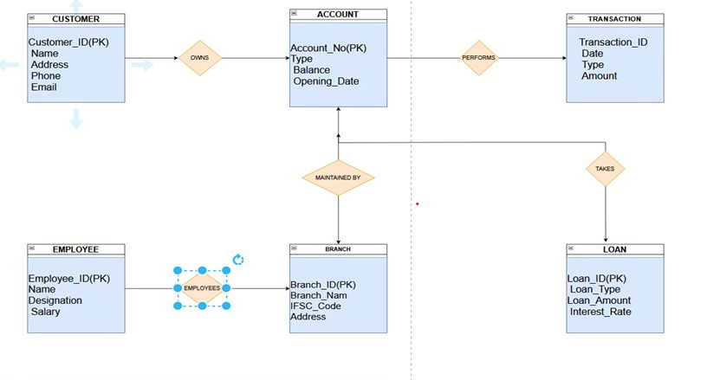

Result
The Bank Management System ER Diagram consists of six main entities: Customer, Account, Branch, Employee, Transaction, and Loan. These entities are connected through relationships such as Customer owns Account, Account performs Transaction, Branch maintains Account, Branch employs Employee, and Customer takes Loan, providing a clear conceptual model for designing the bank database.

Extended ER (EER) Model
The Extended Entity-Relationship (EER) Model is an advanced version of the Entity-Relationship (ER) Model. It includes additional features to represent complex real-world database systems more accurately.

The EER model supports concepts such as:
- Generalization
- Specialization
- Aggregation
- Inheritance
- Categories (Union Types)
It is widely used in designing large and complex databases.

Generalization Definition
Generalization is the process of combining two or more lower-level entities that have common attributes into a higher-level entity called a superclass.

Example
Suppose there are two entities:
  - Savings Account
  - Current Account
Both have common attributes like:
  - Account Number
  - Balance
  - Opening Date
These can be generalized into a superclass called Account.

Diagram
ACCOUNT

Account_No Balance Opening_Date
▲
┌────┴────┐
│ │ │
SAVINGS_ACCOUNT CURRENT_ACCOUNT

Advantages
  - Reduces data redundancy.
  - Improves data organization.

  - Makes database design simpler.

Specialization Definition
Specialization is the process of dividing a higher-level entity (superclass) into smaller lower-level entities (subclasses) based on their specific characteristics.

Example
A Person entity can be divided into:
  - Student
  - Employee Common attributes:
  - Person_ID
  - Name
  - Address Student-specific:
  - Course
  - Semester Employee-specific:
- Salary

Diagram
PERSON

Person_ID Name Address
│
┌─────┴─────┐
│ │ │
STUDENT EMPLOYEE
Course Salary Semester Department

Advantages
  - Represents specific properties clearly.
  - Makes data easier to manage.

  - Supports inheritance.

Aggregation Definition
Aggregation is the process of treating a relationship between entities as a higher-level entity so that it can participate in another relationship.
It is useful when a relationship itself needs to have another relationship.

Example
An Employee works on a Project.
The relationship Works_On is treated as one entity. A Manager supervises this work.

Diagram
EMPLOYEE -------- WORKS_ON PROJECT
│
│
(Aggregation)
│
MANAGER

Advantages
- Represents complex relationships.
- Simplifies database design.
- Improves clarity in large systems.

Advantages of the EER Model
- Represents complex real-world situations.
- Supports inheritance of attributes.
- Reduces redundancy.
- Improves database organization.
- Makes database design more flexible and efficient.

Result
The Extended ER (EER) Model extends the basic ER model by introducing advanced concepts such as Generalization, Specialization, and Aggregation. These concepts help represent

complex database structures more accurately, reduce redundancy, improve organization, and support efficient database design.

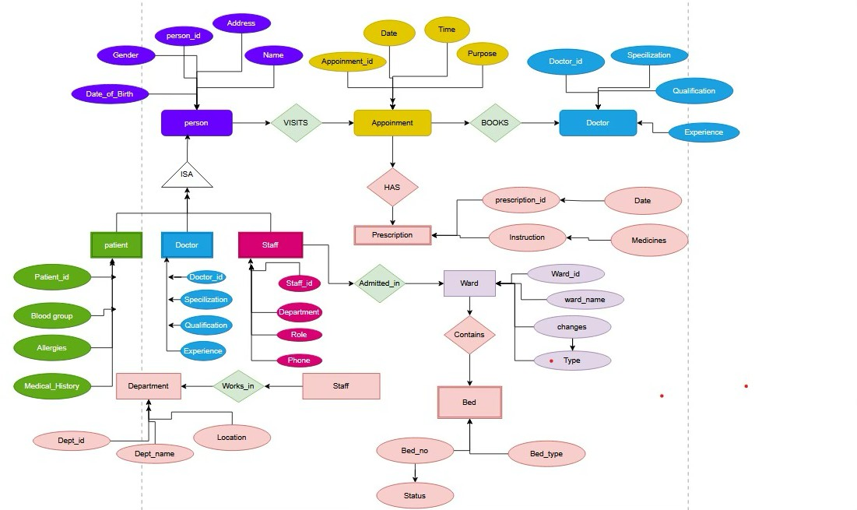
- EER diagram for a Hospital Management System

Role of a DBA (Database Administrator)
A Database Administrator (DBA) is responsible for managing, maintaining, securing, and ensuring the efficient operation of an organization’s databases. The DBA ensures that data is available, accurate, secure, and properly backed up.

Responsibilities of a DBA
- Database Installation and Configuration –
  - Installs and configures database management systems such as MySQL, Oracle, or SQL Server.

Database Design and Creation –

  - Helps design database structures, tables, relationships, and storage methods.

Data Security –
  - Protects the database from unauthorized access by managing users, roles, and permissions.

Backup and Recovery –
  - Regularly backs up data and restores it in case of system failure or data loss.

Performance Monitoring –
  - Monitors database performance and improves the speed and efficiency of database operations.

Data Integrity –
  - Ensures that the stored data is accurate, consistent, and reliable.

User Management –
  - Creates user accounts and assigns appropriate access privileges.

Database Maintenance –
  - Performs regular updates, troubleshooting, and maintenance of the database system.

Disaster Recovery –
  - Develops plans to recover databases after hardware failure, cyberattacks, or other disasters.

Technical Support –
  - Provides support to developers and users for database-related problems.

Conclusion
The DBA plays an important role in database management by ensuring database security, availability, reliability, and performance.

